**Association Rules. The most commonly bought products.**

**Introduction**

By using association rules method, I would like to demonstrate following project; Here, you can see what are the most common products people buy.

**Processing the Data:**

|  |
| --- |
| install.packages("arules")  install.packages("arulesViz")  install.packages("arulesCBA") |
| library(ggplot2)  library(readr)  library(arules)  library(arulesViz) |

**Dataset**

setwd("D:\\R and R Studio\\Association Rules")

getwd()

data<-read.csv("dataset.csv", header=TRUE, sep=";")

names(data)

|  |
| --- |
| [1] "pork..sandwich.bags..lunch.meat..all..purpose..flour..soda..butter..vegetables..beef..aluminum.foil..all..purpose..dinner.rolls..shampoo..all..purpose" |

head(data)

|  |
| --- |
| pork..sandwich.bags..lunch.meat..all..purpose..flour..soda..butter..vegetables..beef..aluminum.foil..all..purpose..dinner.rolls..shampoo..all..purpose  1 shampoo, hand soap, waffles, vegetables, cheeses, mixes, milk, sandwich bags, laundry detergent, dishwashing liquid/detergent, waffles, individual meals, hand soap, vegetables  2 pork, soap, ice cream, toilet paper, dinner rolls, hand soap, spaghetti sauce, milk, ketchup, sandwich loaves, poultry, toilet paper, ice cream, ketchup  3 juice, lunch meat, soda, toilet paper, all- purpose, ,,,,,,,,  4 pasta, tortillas, mixes, hand soap, toilet paper, vegetables, vegetables, paper towels, vegetables, flour, vegetables, pork, poultry, eggs  5 toilet paper, eggs, toilet paper, vegetables, bagels, dishwashing liquid/detergent, cereals, paper towels, laundry detergent, butter, cereals, bagels, paper towels, shampoo  6 paper towels, tortillas, vegetables, milk, ice cream, juice, dishwashing liquid/detergent, soap, sandwich bags, pasta, ketchup, all- purpose, yogurt, mixes |

system("ls ../input")

|  |
| --- |
| [1] 127 |

al<- read.csv('dataset.csv', header=F)

str(al)

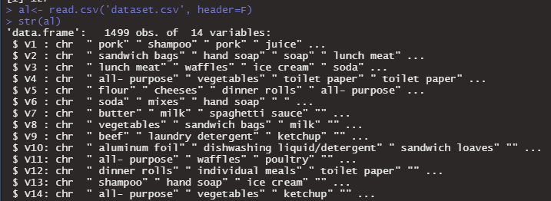

al1<-al[,1:6]

alnan<-as(al1, "transactions")

Here, I set supp=0.001 and conf=0.001, minimum support should be 0.001 and minimum confidence should be 0.001.

rule<-apriori(alnan, parameter = list(minlen=2, maxlen=4, supp=0.001, conf=0.001))

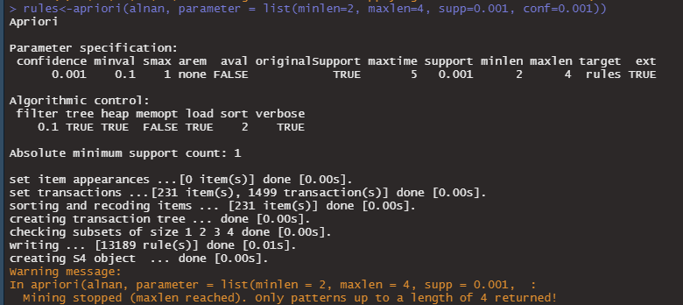

inspect(alnan[1:5])

|  |
| --- |
| items transactionID  [1] {V1= pork,  V2= sandwich bags,  V3= lunch meat,  V4= all- purpose,  V5= flour,  V6= soda} 1  [2] {V1= shampoo,  V2= hand soap,  V3= waffles,  V4= vegetables,  V5= cheeses,  V6= mixes} 2  [3] {V1= pork,  V2= soap,  V3= ice cream,  V4= toilet paper,  V5= dinner rolls,  V6= hand soap} 3  [4] {V1= juice,  V2= lunch meat,  V3= soda,  V4= toilet paper,  V5= all- purpose,  V6= } 4  [5] {V1= pasta,  V2= tortillas,  V3= mixes,  V4= hand soap,  V5= toilet paper,  V6= vegetables} 5 |

inspect(yontem[1:5])

|  |
| --- |
| lhs rhs support confidence coverage lift count  [1] {V5= pork} => {V2= ketchup} 0.001334223 0.10526316 0.01267512 6.068826 2  [2] {V2= ketchup} => {V5= pork} 0.001334223 0.07692308 0.01734490 6.068826 2  [3] {V5= pork} => {V1= cheeses} 0.002001334 0.15789474 0.01267512 7.396382 3  [4] {V1= cheeses} => {V5= pork} 0.002001334 0.09375000 0.02134757 7.396382 3  [5] {V5= pork} => {V6= waffles} 0.001334223 0.10526316 0.01267512 4.781499 2 |

rule<-sort(yontem, by="support", decreasing = T)

inspect(rule[1:5])

|  |
| --- |
| lhs rhs support confidence coverage lift count  [1] {V5= } => {V6=} 0.034022682 1.00000000 0.03402268 29.392157 51  [2] {V6=} => {V5= } 0.034022682 1.00000000 0.03402268 29.392157 51  [3] {V5= vegetables} => {V4= vegetables} 0.009339560 0.12389381 0.07538359 1.326549 14  [4] {V4= vegetables} => {V5= vegetables} 0.009339560 0.10000000 0.09339560 1.326549 14  [5] {V3= poultry} => {V4= vegetables} 0.007338225 0.27500000 0.02668446 2.944464 11  [6] {V4= vegetables} => {V3= poultry} 0.007338225 0.07857143 0.09339560 2.944464 11  [7] {V6= vegetables} => {V4= vegetables} 0.007338225 0.11340206 0.06470981 1.214212 11  [8] {V4= vegetables} => {V6= vegetables} 0.007338225 0.07857143 0.09339560 1.214212 11  [9] {V4= waffles} => {V6= vegetables} 0.006671114 0.22222222 0.03002001 3.434135 10  [10] {V6= vegetables} => {V4= waffles} 0.006671114 0.10309278 0.06470981 3.434135 10 |

plot(yontem, measure=c("confidence", "lift"), shading="support")

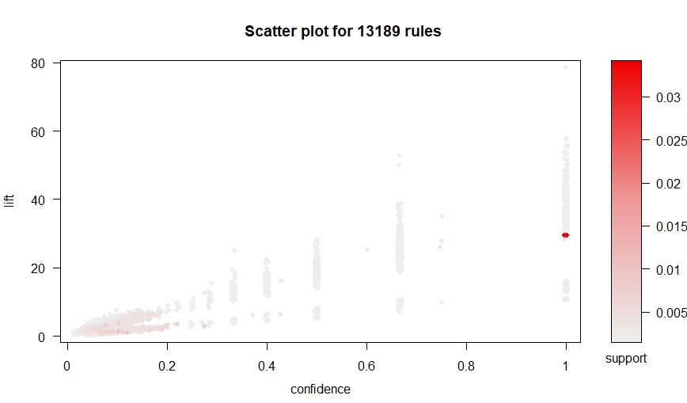

plot(yontem[1:5], method="matrix", measure="lift")

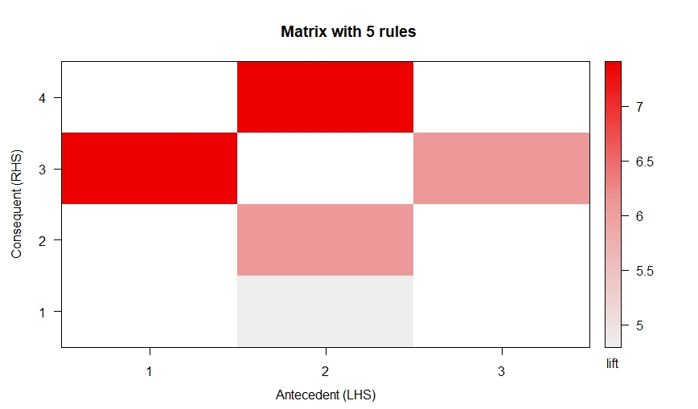

plot(yontem[1:5], method="matrix3D", measure="lift")

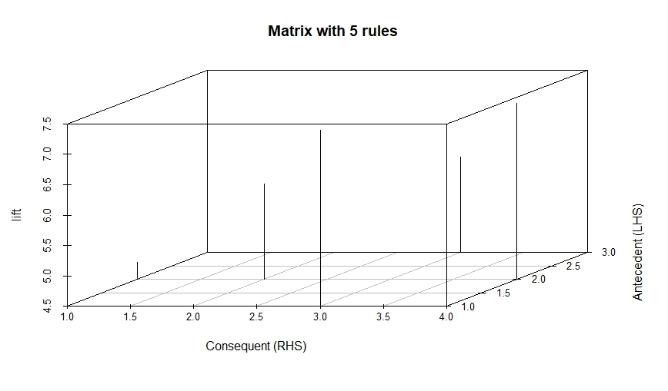

satylan <- head(sort(yontem, by="lift"), 5)

plot(satylan, method="graph")

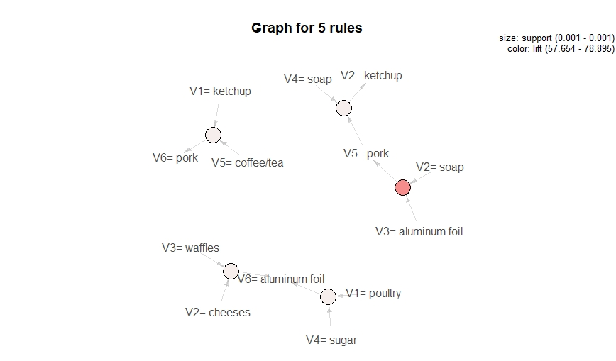

plot(satylan, method="paracoord")

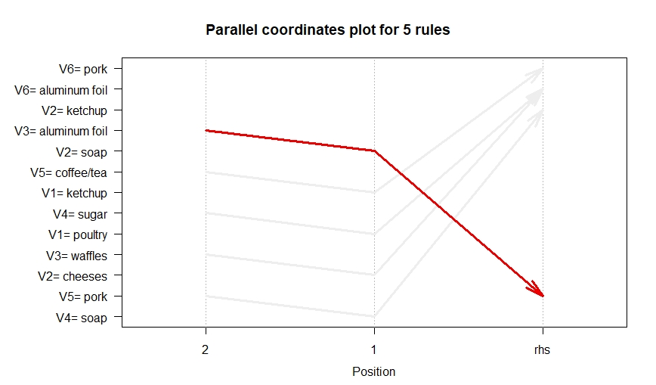

**Conclusions**

In the result you can see (last graph) that list of the products. İt is very useful method to analysis such dataset.

**Reference**

“[What people purchase | Kaggle](https://www.kaggle.com/gorkhachatryan01/purchase-behaviour) “ <-databases if in following link.